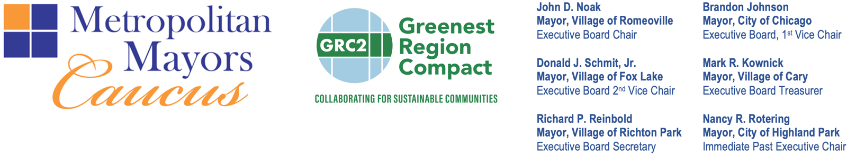

On behalf of the Metropolitan Mayors Caucus, we invite your organization to join recycling, sustainability, municipal, and community partners across Illinois in endorsing a legislative proclamation to designate Loop as the statewide recycling mascot of Illinois.

Loop—the friendly, googly-eyed recycling cart at the heart of the Feed the Cart campaign—was created to make recycling education clear, engaging, and memorable. Since launching in October 2025, Feed the Cart has brought together 275 municipalities across seven counties under a shared recycling education and outreach strategy, demonstrating the power of consistent communications to help residents elevate and improve their recycling practices.

We are asking your organization to endorse the legislative proclamation designating Loop as Illinois’ statewide recycling mascot. Your support will demonstrate that organizations across Illinois see value in a shared, engaging approach to recycling education and in expanding a successful Illinois-born initiative statewide.

The campaign is already producing measurable results. Ten Chicagoland communities collectively report their targeted education campaigns helped reduce recycling contamination from 60% to 37%. Feed the Cart has also generated more than 66.5 million paid and earned media impressions, reaching Illinois residents through digital communications, community engagement, and regional partnerships. In 2026, the National Recycling Coalition recognized Feed the Cart with the Beth Brown Boettner Award for Outstanding Public Education/Outreach Program, honoring the campaign as a scalable, research-based approach to improving recycling participation and reducing contamination.

Now, we have an opportunity to build on that success statewide. Illinois continues to pursue greater recycling participation, reduced contamination, increased landfill diversion, and stronger public understanding of proper recycling practices. Achieving these objectives requires more than infrastructure—it requires clear, consistent education that connects statewide priorities with the decisions Illinois residents make every day.

Designating Loop as Illinois’ recycling mascot would create a recognizable statewide ambassador for that work. Loop could support recycling education in municipalities, schools, community organizations, and public outreach initiatives while complementing the recycling programs and requirements of individual communities.

Please reply YES to jmathey@mayorscaucus.org authorize us to list your organization as an endorsing partner, rather than asking partners like you to draft your own support letters.

Thank you for your partnership and consideration. We hope you will join us in supporting Loop for Illinois.

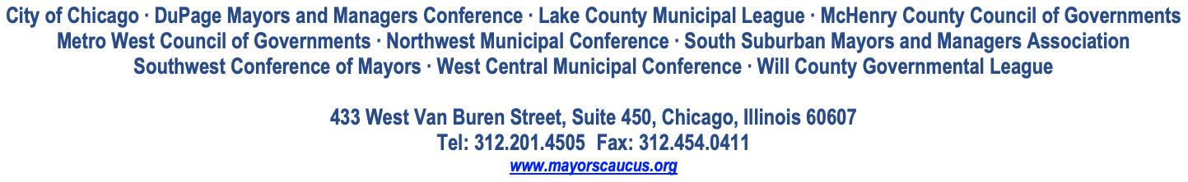
Sincerely,
The Chicago Regional Recycling Education & Outreach Partners

