Low Income Home Energy Assistance Program (LIHEAP)
Sample Website Text

Please feel free to use this sample content on your organization’s website. The table can be downloaded in a few formats at the Caucus’ LIHEAP Sample Visual webpage.

Note that each county’s Community Action Agency (CAAs) processes LIHEAP applications. You may use a sample message directing residents to the general website for LIHEAP (HelpIllinoisFamilies.com) and then add specific information based on your county.

Low Income Home Energy Assistance Program (LIHEAP)

The Low Income Home Energy Assistance Program (LIHEAP) assists residents in paying for home energy bills, primarily heating during the winter. If eligible, a payment will be sent directly to the utility on behalf of a household. If a household’s combined gross income is at or below 200% of the federal poverty level for the 30 days prior to the application, the household may be eligible for assistance. For renters, if heat and/or electric is included in rent, then the rent must be greater than 30% of a resident’s income to be eligible for LIHEAP assistance. The application period is from Sept. 1, 2022, through May 31, 2023, or until funds are exhausted.

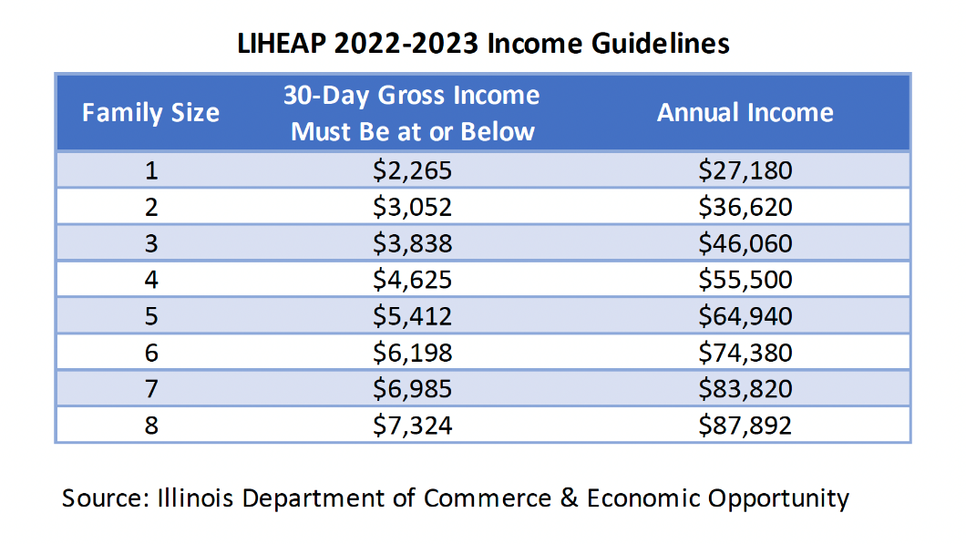

The Illinois Department of Commerce & Economic Opportunity (DCEO) administers the LIHEAP program. Residents can apply for LIHEAP by contacting their local community action agency (CAA) or administering agency, based on their county. Contacting the CAA directly is the fastest method. Another way to apply is by filling out a pre-application at HelpIllinoisFamilies.com and waiting for a call back from a local agency. If a resident is considering LIHEAP, it is recommended to apply because being eligible for LIHEAP can be an indication that an individual is eligible for other income-qualified programs. Income-eligible undocumented workers may also apply for LIHEAP.

When applying to LIHEAP, a newer feature is that residents will also be applying to the Low Income Household Water Assistance Program (LIHWAP) at the same time. Residents will qualify for LIHWAP assistance with water and wastewater bills if their household is disconnected, in threat of disconnection or if they are more than $50 in arrears on their current bill.

For more information, contact your local CAA or call the LIHEAP Hotline at 1-877-411-WARM (9276).

**Please feel free to edit the website text above (second paragraph, also contact information sentence at end) by adding in the specific county information for your residents.

COOK COUNTY
To apply for LIHEAP, review the income guidelines and apply at the Community and Economic Development Association (CEDA) of Cook County website at https://bit.ly/3sOsyhF. If eligible, then the fastest way to apply is by contacting the CEDA intake agency in your area. If you have questions, contact CEDA at 800-571-2332.

DUPAGE COUNTY
For more information and to apply, call DuPage County Community Services at 630-407-6500 or go to: http://bit.ly/3beNfh1

KANE AND DEKALB COUNTIES
To apply for LIHEAP, fill out a request form at the Community Contacts Inc. (CCI) website at http://bit.ly/3qgfLTy and then schedule an in-person interview to complete your application through the CCI website or by calling 847-697-4400.

KENDALL COUNTY
To apply for income-eligible assistance, call Kendall-Grundy Community Action at 630-553-9100 to schedule an appointment.

LAKE COUNTY
To apply for income-eligible assistance, call the Community Action Partnership of Lake County at 847-249-4330 to schedule a phone call appointment.

MCHENRY COUNTY
For more information and to apply, book a phone call appointment with McHenry County Housing Authority at http://bit.ly/3elZFFV or by calling 815-308-6057.

WILL COUNTY
For more information and to apply, contact the Will County Center for Community Concerns by filling out a request form at http://bit.ly/3rh6ITR or apply in person on a walk-in basis.

