Low Income Home Energy Assistance Program (LIHEAP)
Sample Newsletter Articles

Please feel free to use this sample content in your organization’s newsletter or as a starting point for your own personalized article. The table can be downloaded in a few formats at the Caucus’ LIHEAP Sample Visual webpage. In the “How to Apply” section, please choose the county(ies) that your community is in, in order to direct residents to the correct community action agency (CAA).

LONGER NEWSLETTER ARTICLE – CHOICE #1

Energy Bill Assistance Available

The Low Income Home Energy Assistance Program (LIHEAP) provides assistance to residents who are struggling to pay their home energy costs and primarily assists with heating bills. Income-eligible residents can apply for LIHEAP from Sept. 1, 2022, through May 31, 2023, or until funding is exhausted. If eligible and approved for LIHEAP funds, a one-time payment will be sent directly to the utility on behalf of a household.

Households with a combined gross income at or below 200% of the federal poverty level for the 30 days prior to the application may be eligible for assistance. To see if you are eligible, please view the chart below from the Illinois Department of Commerce & Economic Opportunity (DCEO) LIHEAP webpage.

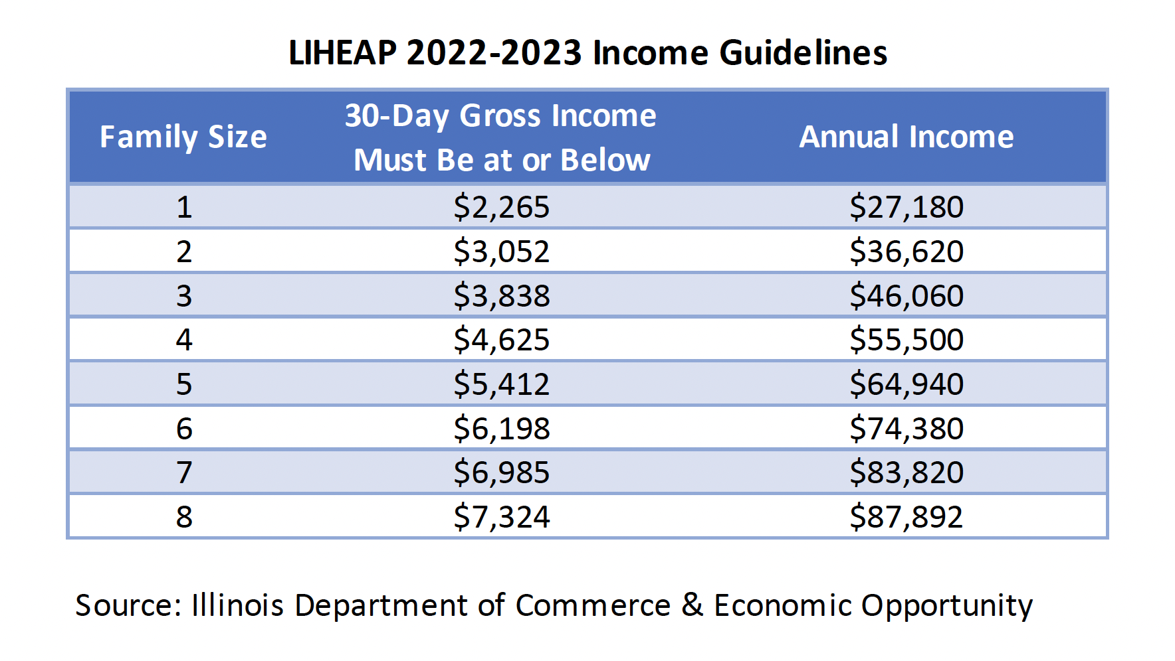

Renters may also be eligible for LIHEAP. If heat and/or electric is included in rent, then the rent must be greater than 30% of a resident’s income to be eligible.

Income-eligible undocumented workers may also apply for LIHEAP state funds.

Water/Sewer Bill Assistance

When applying to LIHEAP, a newer feature is that residents will also be applying to the Low Income Household Water Assistance Program (LIHWAP) at the same time. Residents will qualify for LIHWAP assistance with water and wastewater bills if their household is disconnected, in threat of disconnection or if they are more than $50 in arrears on their current bill.

How to Apply to LIHEAP

COOK COUNTY
To apply for LIHEAP, review the income guidelines and the documents you need to apply at the Community and Economic Development Association (CEDA) of Cook County website at https://www.cedaorg.net/find-services/gas-and-electric/. If eligible, then the fastest way to apply is by contacting the CEDA intake agency in your area, which can be found at the above CEDA website. If you have questions, contact CEDA at 800-571-2332.

DUPAGE COUNTY
To apply for LIHEAP, call DuPage County Community Services at 630-407-6500 or go to: https://www.dupagecounty.gov/LIHEAP/

KANE AND DEKALB COUNTIES
To apply for LIHEAP, fill out a request form at the Community Contacts Inc. website at https://cci-hci.org/liheap-form/ and then schedule an appointment online or by calling 847-697-4400.

KENDALL COUNTY
To apply for LIHEAP, call Kendall-Grundy Community Action at 630-553-9100 to schedule an appointment.

LAKE COUNTY
To apply for LIHEAP, call the Community Action Partnership of Lake County at 847-249-4330 to schedule a phone call appointment.

MCHENRY COUNTY
To apply for LIHEAP, book a phone call appointment with McHenry County Housing Authority online at https://www.mchenrycountyhousing.org/housing-programs/energy-assistance/#LIHEAP or by calling 815-308-6057.

WILL COUNTY
To apply for LIHEAP, contact the Will County Center for Community Concerns by filling out a request form at http://www.wcccc.net/register_w.asp. You can also apply in person on a walk-in basis. Please view the locations, hours, and documentation needed at https://wcccc.net/utility-assistance/.

Other Types of LIHEAP Assistance
- Crisis Assistance
  - Emergency Furnace Assistance – If your household is LIHEAP eligible and your furnace stops working or is deemed unsafe, you may be eligible for assistance. The LIHEAP furnace repair and replacement program ensures that residents have working heat.
  - Reconnection Assistance – Reconnection assistance may be available for households that are disconnected or have received a disconnection notice. The assistance is only provided if it will ensure reconnection and if the household has made a good faith effort to pay its utility bills and/or can pay a portion of the reconnection assistance balance due, when applicable.
- PIPP - The Percentage of Income Payment Plan (PIPP) program is a benefit choice within LIHEAP. The PIPP program is NOT accepting new applications during the period of Sept. 1, 2022, through May 31, 2023, due to the availability of funds and recent energy price increases. If a resident chooses PIPP over the regular LIHEAP program, they will be enrolled in a budget billing plan. The State pays a portion of the monthly budget bill, the resident is required to pay the rest, and the overdue payments are reduced for each on-time payment that is made.

BRIEF NEWSLETTER ARTICLE - CHOICE #2

Energy Bill Assistance Available

The Low Income Home Energy Assistance Program (LIHEAP) is an income-based annual block grant that assists residents in paying for heating bills. If eligible, a payment will be sent directly to the utility on behalf of a household. If a household’s combined gross income is at or below 200% of the federal poverty level for the 30 days prior to the application, the household may be eligible for assistance. For renters, if heat and/or electric is included in rent, then the rent must be greater than 30% of a resident’s income to be eligible. The application period is from Sept. 1, 2022, to May 31, 2023, or until funds are exhausted.

The Illinois Department of Commerce and Economic Opportunity (DCEO) administers the LIHEAP program. Residents can apply for LIHEAP by contacting their local community action agency (CAA) or administering agency, based on their county. Contacting the CAA directly is the fastest method. Another way to apply is by filling out a pre-application at HelpIllinoisFamilies.com and waiting for a call back from a local agency, but it may take days or weeks to receive a response. If a resident is considering LIHEAP, it is recommended to apply because being eligible for LIHEAP can be an indication that an individual is eligible for other income-qualified programs. Income-eligible undocumented workers may also apply for LIHEAP.

