CHECKLIST FOR CS² COMMUNITY SOLAR PROGRAM
The Community Solar Clearinghouse Solution (CS²) Program helps local governments secure the benefits of community solar for their residential and small commercial ratepayers. This checklist identifies the steps required for a municipality to join the CS² Program. For clarity: The CS² Program requires no direct financial investment on the part of local municipalities.
- Complete Expression of interest. Complete the Expression of Interest form at: https://metropolitanmayorscaucus.submittable.com/submit/181541/residential-community-solar-clearinghouse-solutions-program-cs2-expression-of
- Consult with The Power Bureau. Schedule a brief interview and consultation with Mark Pruitt of The Power Bureau (markjpruitt@thepowerbureau.com, 219-921-3828).
- Approve Subscription Terms and Participation. Municipalities must approve the commercial terms that the CS² Program negotiates with community solar developers. Early adopters will likely capture the best terms.
Attachment A: A set of model commercial terms for the community solar subscriptions.
- Pass a Resolution. The CS² Program requires that participating municipalities pass a resolution indicating that they approve of participation in the CS² Program.
Attachment B: A model resolution to be customized for Board action.
- Submit Endorsement Letter. The Illinois Power Agency requires that parties that endorse a community solar offer submit an Endorsement Letter.
Attachment C: A model Endorsement Letter to be submitted to the CS² Program Billing Administrator.
- Please provide us with a mailing list of your residents and businesses. The list will be used to mail residents and small businesses a postcard about the community solar program. The mailing list can be from water billing software, tax records, an emergency notification system, or any other updated list that your municipality keeps.
6.5 Upload your municipal logo to the Submittable website in .png format, for use on the postcard.
- Register as a Marketing Designee. The Illinois Power Agency requires that parties that recommend community solar subsriptions to consumers be registered as Market Designees - including municipalities.
Attachment D: A step-by-step guide to registering as a Market Designee.
7.5 Indicate the community solar webpage and the physical address of your municipality that should be listed on the postcards to residents.
- Please let us know on the Submittable website whether you will create a municipal webpage for the community solar program that will appear on postcards (See step #9 for example text and webpages.) or if you would like to display the general MC Squared Energy Services, LLC website on the postcards, which is: https://www.mc2energyservices.com/IL/Community-Solar/Join-The-Waitlist
- In addition to the webpage, please let us know the physical address of your municipal building that you would like listed on the postcard.

- Edit and Approve the Direct Mailer. MC Squared Energy Services, LLC will cover the cost of a mailer to all of your residents.
Attachment E: A sample postcard mailer and indicators for necessary update.
- Upload Program Materials to Municipal Website. The Program works best when residents can verify that the community solar offer is explained on the municipal website. Consider what information you want to provide to your residents.
Attachment F: Sample text that can be edited for use and posting on your municipal website.
- Sign Up Municipal Accounts. Consider leading by example by enrolling some municipal accounts into the program (e.g., accounts served under the Watt-Hour or Small Commercial rate classes).

SAMPLE COMMERCIAL TERMS FOR CS² COMMUNITY SOLAR PROGRAM
The commercial terms outlined below were adopted by the first communities to use the CS² Program for their residents (e.g., Village of Oak Park, North Shore Consortium). The CS² Program secured commitments from community solar developers to offer a limited volume of subscriptions that met these terms.
Key Commercial Terms for CS² Community Solar Program
Net Metering Credit Split | - Subscriber receives 100% of all utility net metering credits on the monthly utility bill.  - Subscriber pays 80% of all monthly net metering credits through electronic billing
Eligible Accounts | - Residential and Small Commercial accounts receiving service from Ameren Illinois or ComEd  - Must remain on utility default tariff rates
Enrollment Requirements | - No credit check or minimum credit score  - $0 enrollment fees
Agreement Term | - Up to 15-20 years  - Subscription sale and transfers allowed
Subscription Termination | - $0 termination fees with 60 days’ notice  - Termination for non-payment or placement on non-Default tariff rates for 2 consecutive billing cycles
Consumer Services | - Online enrollment, electronic billing, call center, program website  - Services paid by community solar farm developers
Marketing Costs | - Mailings, press releases, municipal website content  - Paid by community solar farm developers

Because of the limited availability of community solar projects in the ComEd region, communities may not be able to secure the same terms noted above. The CS² Program will present the best terms available in the market on an ongoing basis, and municipalities can determine whether to accept those amended terms prior to fully participating in the program.

SAMPLE RESOLUTION Endorsing the cS² Program

RESOLUTION OF VILLAGE/TOWN/CITY OF _________________
WHEREAS, the Metropolitan Mayors Caucus provides a forum for the chief elected officials of the Chicago region to develop consensus and act on common public policy issues and multi-jurisdictional challenges; and
WHEREAS, the Metropolitan Mayors Caucus has a history of environmental stewardship, from energy efficiency, water conservation, urban forestry, and participation in the Greenest Region Compact; and
WHEREAS, it is important for Mayors and local governments throughout Illinois to take leadership roles to advance sustainability both in their own communities and in concert with regional, national and global initiatives; and
WHEREAS, to facilitate local support of new solar development in Illinois, the Metropolitan Mayors Caucus created the Community Solar Clearinghouse Solution (CS²) Program (herein “Program”) which will allow residents to support the development of shared solar resources in Illinois without the need to install solar panels on their homes and properties through subscriptions. By obtaining a subscription, a resident can reduce their total cost of electricity supply by receiving net metering credits on their monthly utility bills; and,
WHEREAS, the Program will assist the [“City/Town/Village”] of [________________]in its ongoing effort to provide residents with access to sustainable energy solutions that enhance the quality of life for residents along with protection and stewardship of the environment and sustainable economic vitality; and
WHEREAS, the [“City/Town/Village”] [“Manager”, “Staff”] has recommended the approval and endorsement of the Community Solar Clearinghouse Solution Program to the [“Mayor”, “President”] and the [“Members”, “Trustees”] of the [“Board”, “Council”], and agrees to educate and inform residents regarding its availability;
NOW, THEREFORE, BE IT RESOLVED that the [“City/Town/Village”] of [________________] endorses the Community Solar Clearinghouse Solution (CS²) Program proposed by the Metropolitan Mayors Caucus and agrees to educate and inform residents regarding its availability; and
BE IT FURTHER RESOLVED by the [“Mayor”, “President”] and the [“Board”, “Council”] that the [“City/Town/Village”] [“Manager”, “Staff”, “President”, Mayor”] or designee is hereby authorized to execute any necessary documents to assure access for residents of the Program.

ENDORSEMENT LETTER
[City/Town/Village Letterhead]
[DATE]

Chuck Sutton
President

MC Squared Energy Services, LLC.
175 West Jackson Blvd.
Suite 240
Chicago, IL 60604

Dear Mr. Sutton;
We are pleased to inform you that we have reviewed your proposed community solar subscription program terms for an offer available to all [City/Town/Village] of _______________ [“City/Town/Village”] residents, and we are authorizing MC Squared Energy Services, LLC (“MC Squared”) to represent that the [City/Town/Village] endorses the community solar subscription offer.
We understand that in order to claim that the [City/Town/Village] endorses a community solar subscription offer in a system participating in the Illinois Power Agency’s (“IPA”) Adjustable Block Program (“ABP”), the IPA or its designee must approve MC Squared’s offer to our residents (on behalf of the “Approved Vendors” for those community solar systems). We understand that the IPA has granted this approval for similar subscription programs. We are writing this letter in support of MC Squared’s pending request for such approval for the [City/Town/Village].
On [date], the [City/Town/Village] Board voted to grant [City/Town/Village administration] the ability to endorse a community solar subscription program for residential and small commercial customers within the [City/Town/Village]’s limits. The key terms of the offer, for which the [City/Town/Village] grants MC Squared and associated Approved Vendors the right to claim the [City/Town/Village]’s endorsement, include:
- The subscriber is guaranteed to save/retain an amount equal to [XX]% of the net metering credit as long as the customer is receiving electricity supply service on the [Commonwealth Edison, Ameren Illinois] bundled electricity supply service;
- A customer may terminate at any time upon 60 days’ notice;
- There are no early termination fees; and
- MC Squared will handle invoicing and customer care on behalf of the project.

The endorsed subscription offer may be for any community solar project within the [Commonwealth Edison, Ameren Illinois] service territory that is participating within the IPA ABP where MC Squared is providing subscriber acquisition, subscriber management/customer care, and invoicing services to the system.
This letter does not obligate the [City/Town/Village] to undertake any additional actions on behalf of MC Squared with regard to the endorsed subscription offer, including but not limited to an opt-out municipal aggregation pursuant to Section 1-92 of the Illinois Power Agency Act. It is the exclusive responsibility of MC Squared and the associated Approved Vendors to remain in compliance with the requirements of the IPA’s Adjustable Block Program.

The [City/Town/Village] may revoke its endorsement at any time. In such event, MC Squared and associated Approved Vendors shall promptly take steps to remove any marketing materials claiming the Village’s endorsement.
Please let us know if you need additional information in support of your request.
Sincerely,

[Signatory]
Attachment: Meeting Minutes

register as a designee
All municipalities must register as a Designee with the Illinois Power Agency at: https://illinoisabp.com/

- Navigate to the Illinois Adjustable Block Program Portal and select Login link (white dashed box below):
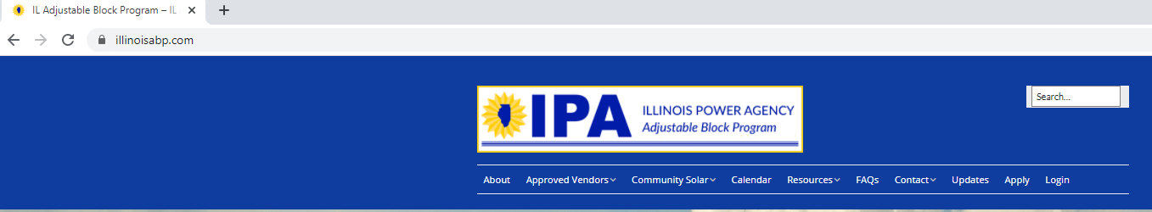

- Create a new account by selecting the [Create an Account link] from the login page (red dashed box below)
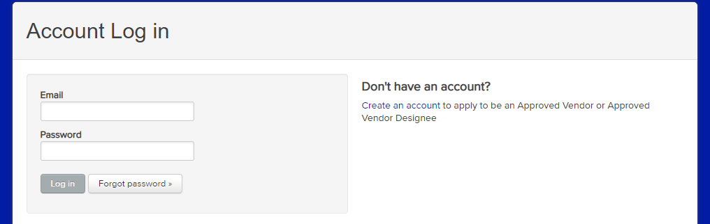

- Complete the User Registration and select the [Create Account] button (red box below)

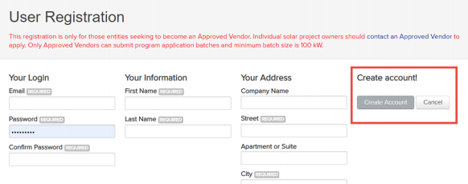

- You will receive an email from the Program Administrator that contains a link to activate the account. Click on the link to access the [Designee Registration] (red box below) in Vendors Dashboard (blue box below).
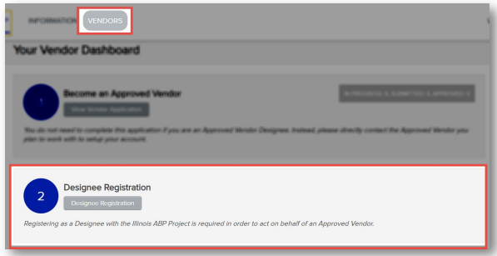

- The Approved Vendor Designee Registration screen provides a disclosure about the purpose of the Designee registration and the Designee’s responsibility to comply with all program requirements. Select [Marketing or Sales Organization] (red box below).
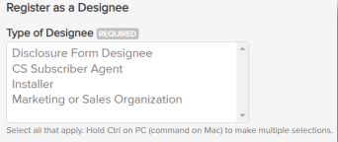

- Confirm Contact Information
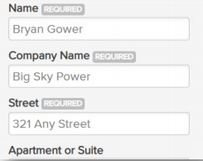

- Leave social media links blank and click on [Submit] (red box below).
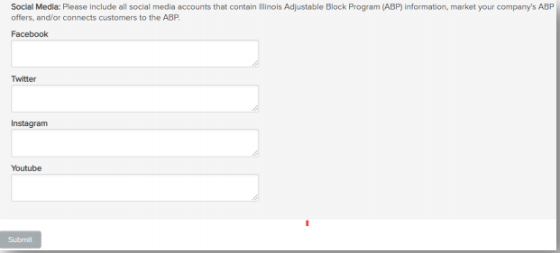

- Download Marketing Guidelines and Program Guidebook (Red box below) and enter initials for each attestation
Highlight the marketing manual elements that matter
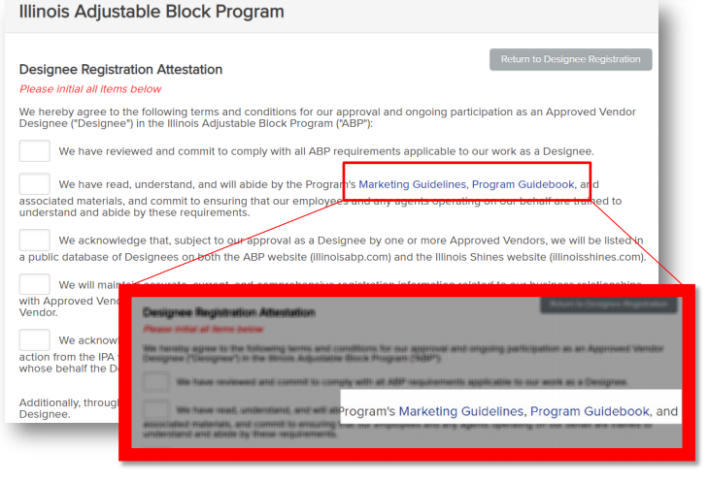

- Submit Electronic Signature (red box below)
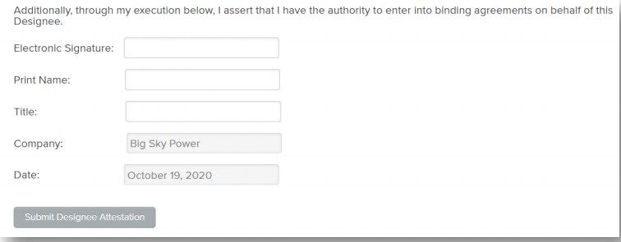

- Copy and Send your Designee Registration through the Metropolitan Mayors Caucus Submittable website, where you had initially filled out the Expression of Interest form. https://metropolitanmayorscaucus.submittable.com/submit/181541/residential-community-solar-clearinghouse-solutions-program-cs2-expression-of

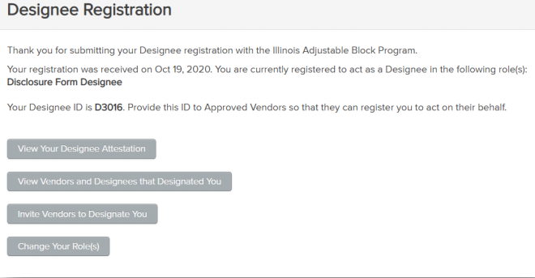

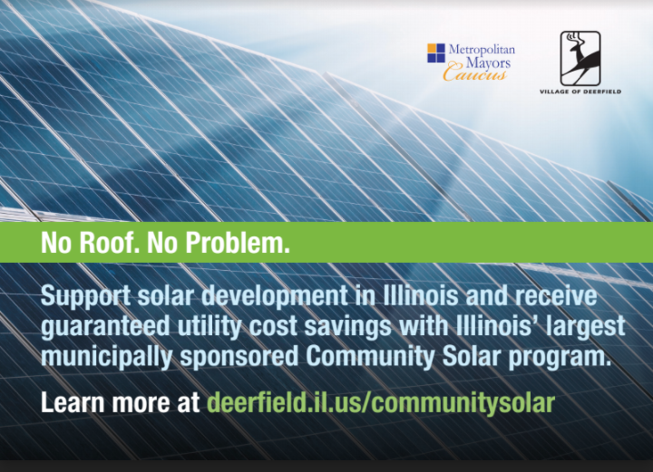
- Approve landing site address:
- An address on existing municipal website; or,
- The program landing site.
- Submit municipal logo

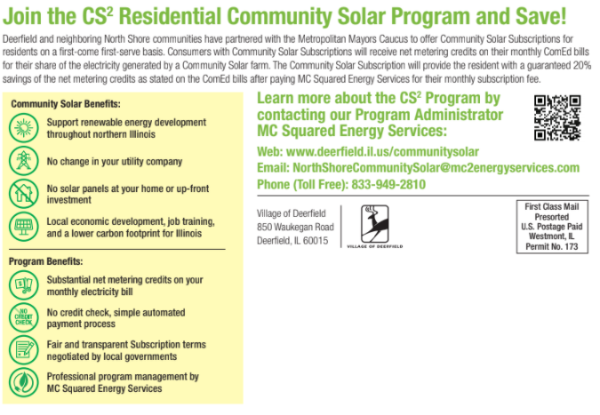
C. Select
- Municipal web address

insert program description on muncipal website

Community Solar
The [City/Town/Village} of ___________ has partnered with the Metropolitan Mayors Caucus to launch the state's largest community solar program called the CS² Residential and Small Commercial Program, which provides consumers easy and immediate access to new community solar farms in northern Illinois.

What Is Community Solar?
A community solar project is a single site solar installation that is shared by multiple consumers (termed
“subscribers”). Each subscriber receives net metering credits for their share of the electricity generated by their community solar installation (termed “net metering credits”). These net metering credits reduce the amount of electricity charged to the subscriber’s account each month to yield cost savings. With community solar, subscribers can reduce their monthly electric bills with solar without installing solar panels on their house or business.
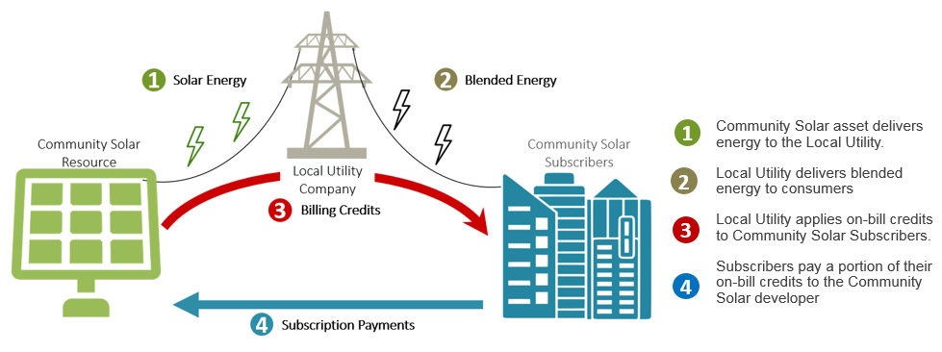
Benefits of Community Solar
Subscribers will receive a guaranteed XX% savings of the community solar credits they receive on their bill. It is also an easy way to support clean energy generation in Illinois. In addition, you do not have to invest in solar rooftop panels, which may not be right for everyone.
How to Sign Up?
Visit www.xxxxxxxx.com to join the waitlist. You will need your utility bill handy. You are not obligated to participate by putting your name on the waitlist. The Program’s Billing Administrator, MC Squared Energy Services, LLC, will be handling all of the sign-ups and account administration. Once you have submitted your information, they will contact you when a solar farm is ready.
How Does Billing Work?
It is a two-stage process. After successfully completing the enrollment process, you will receive net metering credits on your monthly utility bill. Then, after you have received your net metering credits from the utility, MC Squared Energy Services, LLC will bill you for XX% of the net metering credits - leaving you with XX% of all net metering credits. You will also be able to see how your participation helps the environment each month!
For more detailed information on billing and for other Frequently Asked Questions, please click here. You do not need to contact the [City/Town/Village] of ___________ to participate in the program. However, if you have questions or problems signing up, please call [NAME], [TITLE] at XXX/XXX-XXXX.

The Village of [City/Town/Village] of _____________ understands that MC Squared has entered into contractual arrangements with Approved Vendors to obtain, manage, and invoice subscribers, but that MC Squared does not own or operate any of the facilities.

