insert program description on muncipal website

Community Solar
The [City/Town/Village} of ___________ has partnered with the Metropolitan Mayors Caucus to launch the state's largest community solar program called the CS² Residential and Small Commercial Program, which provides consumers easy and immediate access to new community solar farms in northern Illinois.

What Is Community Solar?
A community solar project is a single site solar installation that is shared by multiple consumers (termed
“subscribers”). Each subscriber receives net metering credits for their share of the electricity generated by their community solar installation (termed “net metering credits”). These net metering credits reduce the amount of electricity charged to the subscriber’s account each month to yield cost savings. With community solar, subscribers can reduce their monthly electric bills with solar without installing solar panels on their house or business.
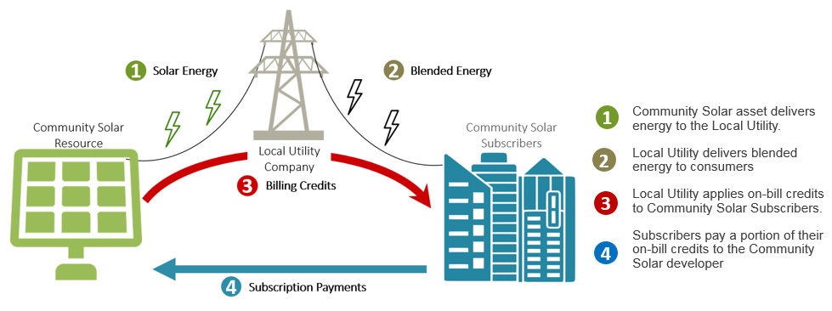
Benefits of Community Solar
Subscribers will save XX% off the supply portion of their electricity bill. It is also an easy way to support clean energy generation in Illinois. In addition, you do not have to invest in solar rooftop panels, which may not be right for everyone.
How to Sign Up?
Visit www.xxxxxxxx.com to join the waitlist. You will need your utility bill handy. You are not obligated to participate by putting your name on the waitlist. The Program’s Billing Administrator, MC Squared Energy Services, LLC, will be handling all of the sign-ups and account administration. Once you have submitted your information, they will contact you when a solar farm is ready.
How Does Billing Work?
It is a two-stage process. After successfully completing the enrollment process, you will receive net metering credits on your monthly utility bill. Then, after you have received your net metering credits from the utility, MC Squared Energy Services, LLC will bill you for XX% of the net metering credits - leaving you with XX% of all net metering credits. You will also be able to see how your participation helps the environment each month!
For more detailed information on billing and for other Frequently Asked Questions, please click here. You do not need to contact the [City/Town/Village] of ___________ to participate in the program. However, if you have questions or problems signing up, please call [NAME], [TITLE] at XXX/XXX-XXXX.

