Village Owned Vacant Lot Community Garden Reimbursement Form

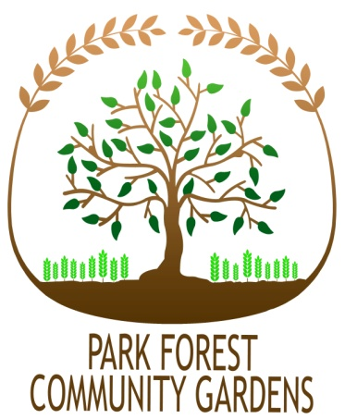
Garden Liaison: ______________________________________________________
Phone number: ______________________________________________________
Email: ______________________________________________________
Garden Address: ______________________________________________________
Mailing Address: ______________________________________________________
How would you like to collect your reimbursement (select ONE)?
___Please Mail it to me ___I will pick it up at Village Hall

Park Forest Village Owned Vacant Lot Community Garden Grant

- Reimbursement will only be made for expenses that directly and solely support the installation and maintenance of the Community Garden on Village-owned property.
- Examples of items for which expenses will be reimbursed include seeds, soil, mulch, materials for planting beds or shade structures, and rain barrels.
- Reimbursement will NOT be made for gardening tools.
- All requests for reimbursement must be accompanied by receipts. Receipts must be dated after March 15th and submitted before November 1st of the gardening year.
- Please itemize all receipts below.
- In order to receive reimbursement, the Designated Liaison must provide the Village with a W9.
- A maximum of two (2) requests for reimbursement can be submitted by each Garden Group per year, with a total yearly reimbursement not exceeding the maximum amount of $250.
- Garden Groups or individuals gardening on vacant lots affiliated with schools, houses of worship, or incorporated non-profits are also eligible to apply for an additional grant through the Park Forest Community Garden Grant Program. A maximum of 20 grants will be awarded each calendar year with a maximum of $100 per grantee. To be considered for a grant through that program, please fill out the separate Park Forest Community Garden application form.

- Return to: Carrie Malfeo, Sustainability Office, 226 Forest Blvd., Park Forest, IL 60466

Date | Description of Purchase | Amount
Total

Office Use:
Date received:
Approved by:
Budget code:

