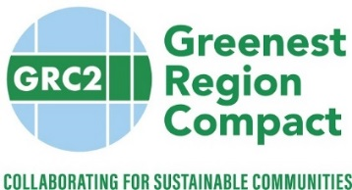
Metropolitan Mayors Caucus
Environment Committee Meeting Description
Sustainable Paving – Warm Mix Asphalt

January 22, 2019, 1:00 AM to 3:00 PM
Illinois Tollway Headquarters, 2700 Ogden Avenue, Downers Grove, IL 60515

Asphalt is a municipal staple that is procured by nearly every municipality for essential road maintenance. A more sustainable option, called warm mix asphalt can be produced by local asphalt plants with minor modifications in their processes. Produced and used at lower temperatures, warm mix asphalt can significantly reduce air pollution and save energy. Using warm mix asphalt (WMA) instead of traditional hot-mix asphalt (HMA) can result in a 50% reduction in the emission of volatile organic compounds (VOC); 60-70% reduction in the pollutant NOx; 30-40% reduction in CO2 emissions; and more. The USEPA is interested in promoting WMA for these considerable environmental benefits and we invite a dialogue with the Environment Committee about this technology.

Warm mix asphalt is not yet widely used by municipalities, yet foundational work to allow for its broader adoption has been done. IDOT has conducted research on WMA and approves its use. The Illinois Tollway Authority has conducted research on WMA and currently maximizes its use in place of hot-mix asphalt on all program projects. Many members of the Illinois Asphalt Pavement Association are able to produce WMA to meet demands.

Experts from these agencies will join us for a conversation to explore the potential for municipalities to use WMA to address sustainable mobility, energy and air quality goals of the Greenest Region Compact.

