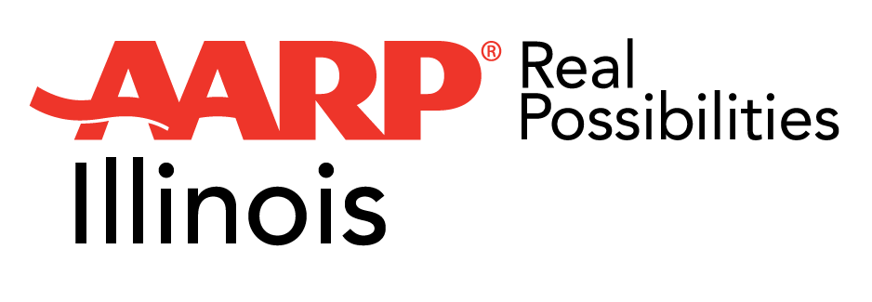
FOR IMMEDIATE RELEASE
July 24, 2018

CONTACT
Dina Anderson
(312) 458-3611
dianderson@aarp.org

AARP Community Challenge Awards Grants to Chicago Area Recipients

Projects led by CDOT, Metropolitan Mayors Caucus and Village of Bull Valley will improve pedestrian safety and demo new housing models for older Illinoisans

CHICAGO—AARP has announced the awardees for its 2018 AARP Community Challenge grant program, including two projects in the Chicago area. A total of $1.3 million will be distributed to fund 129 “quick action” projects across the country, helping communities make immediate improvements and jumpstart long-term progress to support residents of all ages. Nearly 1,600 applications were received from non-profits and government entities for the program, now in its second year. Each of the projects, which must be completed by November 5, is designed to achieve on one or more of the following outcomes:
- Deliver a range of transportation and mobility options that increase connectivity, walkability, bikeability, and/or access to public and private transit.
- Create vibrant public places that improve open spaces, parks and access to other amenities.
- Support the availability of a range of housing that increases accessible and affordable housing options.
- Address other issues of importance for communities.

Grantees in the Chicago area are:
- The Chicago Department of Transportation, which will install temporary “People Places” in parking lanes along a commercial corridor and sidewalk enhancements to improve pedestrian safety, community engagement and economic development in low- and moderate-income neighborhoods.
- The Metropolitan Mayors Caucus and the Village of Bull Valley, which together will create a demonstration accessory dwelling unit (ADU) and hold three Granny Flat Academies throughout the Chicago metropolitan area to increase awareness and production of this housing type.

“We are so proud to support CDOT, the Metropolitan Mayors Caucus and the Village of Bull Valley with these demonstrations,” said AARP Illinois State President Rosanna Márquez. “Livable, walkable, multigenerational communities are crucial to helping Illinoisans age where they want—in their own homes, instead of costly institutions. We’re exciting to see the results of these quick action projects, and look forward to working with community leaders to make the Chicago area more livable.”

“People Places offer community residents the opportunity to interact with their neighbors in a safe public environment,” said CDOT Commissioner Rebekah Scheinfeld. “They help improve a neighborhood's quality of life by promoting walkability and economic development.”

"If this demonstration project can encourage others to follow suit, the Village will be able to retain some of its most respected Village Founders and with them the historical knowledge that affirms and solidifies our Village character and philosophy,” said Village of Bull Valley President Emily Berendt.

The Community Challenge grant program is part of AARP’s nationwide Livable Communities initiative that helps communities become great places to live for residents of all ages. AARP staff and volunteers are working with roughly 300 communities across the country, engaging and mobilizing community residents, delivering technical assistance and expertise to local leaders and organizations, and supporting the work of the 275 communities and two states that have enrolled in the AARP Network of Age Friendly States and Communities. AARP also provides resources and publications to encourage local action such as the Roadmap to Livability and the AARP book-series Where We Live: Communities for All Ages.

“AARP has teams on the ground in communities across the country who hear from mayors, community leaders and local residents about the value of getting quick wins to create long-term change. We developed the Community Challenge Grant Program to answer that call and help build momentum for more livable communities nationwide,” said Nancy LeaMond, AARP Executive Vice President, Community, State and National Affairs. “This year, we are proud to fund more projects in more communities in all 50 states, Washington, D.C. and Puerto Rico.”

The full list of grantees can be found at www.aarp.org/communitychallenge.

To learn more about AARP’s livable communities work in communities across the country and the AARP Community Challenge please visit www.aarp.org/livable.

AARP is the nation’s largest nonprofit, nonpartisan organization dedicated to empowering Americans 50 and older to choose how they live as they age. With nearly 38 million members and offices in every state, the District of Columbia, Puerto Rico, and the U.S. Virgin Islands, AARP works to strengthen communities and advocate for what matters most to families with a focus on health security, financial stability and personal fulfillment. AARP also works for individuals in the marketplace by sparking new solutions and allowing carefully chosen, high-quality products and services to carry the AARP name. As a trusted source for news and information, AARP produces the world’s largest circulation publications, AARP The Magazine and AARP Bulletin. To learn more, visit www.aarp.org or follow @AARP and @AARPadvocates on social media.

###

