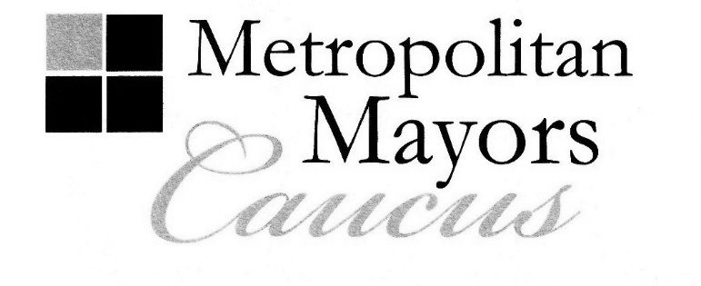
Robert J. Nunamaker
President, Village of Fox River Grove
Executive Board Chairman
Rahm Emanuel
Mayor, City of Chicago
Executive Board 1st Vice Chair

Joseph Mancino
Mayor, Village of Hawthorn Woods
Executive Board 2nd Vice Chair

John A. Ostenburg Mayor, Village of Park Forest
Executive Board Secretary

AGENDA
Executive Board Meeting
Monday, January 9, 2017
9:00 a.m.
Du Page Mayors and Managers Conference
1220 Oakbrook Road
Oak Brook, IL

(The Du Page Mayors and Managers Conference is located on the northwest corner of the
intersection of Jorie Boulevard and Oakbrook Road. Oakbrook Road is also known as 31st Street.)

I. Call to Order and Welcome - President Robert J. Nunamaker, Village of Fox River Grove
Executive Board Chairman
- Welcome New Staff Person: Brian Tomkins, Project Assistant, Environmental Initiatives

II. Approval of Minutes: November 14, 2016 Meeting (Attachment 1)
Action Requested: Motion to approve minutes

III. 9th Annual Gala Update
A. Attendance
B. Sponsorships
C. Time Schedule
D. Hotel Lincoln Rooms
E. Comedy Improv Show Topics (Handout)
Action Requested: Select Topics for Show, Encourage Other Municipal Officials to
Attend

IV. Policy Area: Legislative - Mayor Gerald R. Bennett, City of Palos Hills
Policy Area Leader
A. Recommended 2017 Priorities Statement (Attachment 2)
Action Requested: Motion to Approve Recommended Priorities Statement
B. January 9-10 Lame Duck Session
1. Governor Rauner’s Property Tax Freeze Proposal: HB 6630
2. Lead in Drinking Water Amendment: SB 550
3. FY 2017 Budget Update
4. Other
Action Requested: Discussion

City of Chicago ∙ DuPage Mayors and Managers Conference ∙ Lake County Municipal League ∙ McHenry County Council of Governments

Metro West Council of Governments ∙ Northwest Municipal Conference ∙ South Suburban Mayors and Managers Association

Southwest Conference of Mayors ∙ West Central Municipal Conference ∙ Will County Governmental League

233 South Wacker Drive, Suite 800, Chicago, Illinois 60606

Tel: 312.201.4505 Fax: 312.258.1851

www.mayorscaucus.org

AGENDA
Executive Board Meeting
January 9, 2017
Page 2

V. Policy Area: Housing and Community Development - Mayor Jeffrey T. Sherwin, City of Northlake

Policy Area Leader

A. Diversity Task Force Meeting: January 10, 2017, Hanover Park Police Department, 9:30 a.m.

Action Requested: Information only

B. Northwest Suburban Landlord Workshop: February 22, 2017, Oakton Community College,

Des Plaines, IL

Action Requested: Information only

C. Illinois Governor’s 2017 Conference on Housing: March 13-14, 2017, Hyatt Regency Chicago

Hotel, 151 East Wacker Drive, Chicago, IL

Action Requested: Information only

VI. Policy Area: Environment - Mayor John A. Ostenburg. Village of Park Forest

Policy Area Leader

A. Public Sector Energy Efficiency Grant Program Update

Action Requested: Discussion

B. Powering Safe Communities Grant Program

Action Requested: Discussion

C. Solar Planning, Zoning and Permitting Workshop: January 19, 2017, Prairie Center for the

Arts, Schaumburg, IL

Action Requested: Information only

D. Next Environment Committee Meeting: January 19, 2017, Prairie Center for the Arts,

Schaumburg, IL, 9:30 a.m.

Action Requested: Information only

VII. Policy Area: Transportation - Mayor Jeffery D. Schielke, City of Batavia

Policy Area Leader

A. Meeting with Metra re Uber Marketing/Advertising Agreement: January 9, 2017, Oak Brook

Village Hall, 11:00 a.m. (Attachment 3)

Action Requested: Interested Board Members Encouraged to Attend Meeting to Follow

At Oak Brook Village Hall

VIII. Other Business

IX. Next Board Meeting: March 13, 2017, CMAP/Mayors Caucus Offices, Chicago, IL, 9:30 a.m.

X. Adjournment

