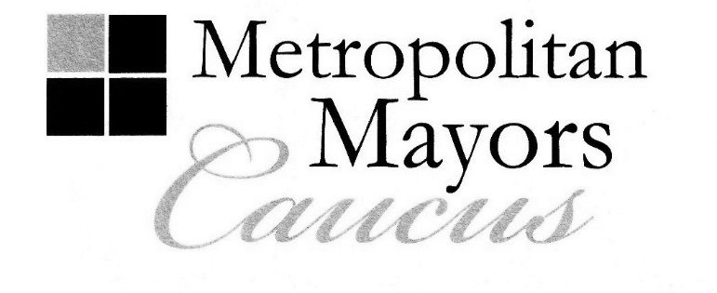
Jim Holland
Mayor, Village of Frankfort
Executive Board Chairman
Rahm Emanuel
Mayor, City of Chicago
Executive Board 1st Vice Chair

Robert J. Nunamaker
President, Village of Fox River Grove
Executive Board 2nd Vice Chair

Joseph Mancino
Mayor, Village of Hawthorn Woods
Executive Board Secretary

AGENDA
Diversity Issues Task Force
Tuesday, September 13, 2016
9:00 a.m.

Metropolitan Mayors Caucus/CMAP Offices
233 S. Wacker Drive, Suite 800
Chicago, IL 60606

9:00 a.m. I. Welcome and Introductions
Mayor Bill McLeod, Village of Hoffman Estates, Task Force Co-Chair
Mayor Rodney Craig, Village of Hanover Park, Task Force Co-Chair

9:05 a.m. II. MPC Cost of Segregation Study
Marisa Novara, Metropolitan Planning Council

9:35 a.m. III. U.S. Supreme Court and Immigration Executive Actions
Qoc’avib Revolorio, Latino Policy Forum

10:00 a.m. IV. National League of Cities' Race, Equity and Leadership (REAL) Council
Mayor John Ostenburg, Village of Park Forest

10:25 a.m. V. Other Business
Discuss meeting schedule

10:35 a.m. VI. Adjourn

City of Chicago ∙ DuPage Mayors and Managers Conference ∙ Lake County Municipal League ∙ McHenry County Council of Governments

Metro West Council of Governments ∙ Northwest Municipal Conference ∙ South Suburban Mayors and Managers Association

Southwest Conference of Mayors ∙ West Central Municipal Conference ∙ Will County Governmental League

233 South Wacker Drive, Suite 800, Chicago, Illinois 60606

Tel: 312.201.4505 Fax: 312.258.1851

www.mayorscaucus.org

