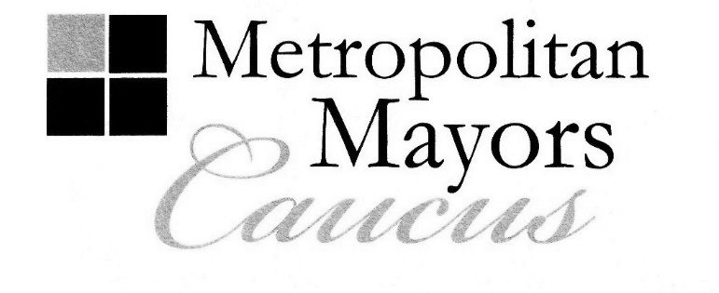
Daniel J. McLaughlin
Mayor, Village of Orland Park
Executive Board Chairman

Rahm Emanuel
Mayor, City of Chicago
Executive Board Vice Chairman

Jim Holland
Mayor, Village of Frankfort
Executive Board Secretary

AGENDA
Executive Board Meeting
Friday, July 10, 2015
10:30 a.m.

Chicago Cultural Center
78 East Washington Street
Millennium Park Room, 5th Floor
Chicago, Illinois

(The Chicago Cultural Center is located on Michigan Avenue between Washington and Randolph Streets.
Convenient parking is located in the Millennium Park Garage and, Grant Park North Garages.)

- Call to Order and Welcome – Mayor Daniel J. McLaughlin, Orland Park
Executive Board Chairman

- Approval of Minutes: May 11, 2015 Meeting (Attachment 1)
Action Requested: Motion to approve minutes

III. Presentation: Update on ComEd’s State Legislative Agenda
Guests: Isaac Akridge, Vice President, Regulatory Projects
Kate Agasie, Stakeholder Outreach Manager
ComEd
Action Requested: Q & A

IV. Policy Area: Housing and Economic Development – Mayor Jeffrey T. Sherwin, City of Northlake
Policy Area Leader
A. Housing and Community Development Committee 2015 Policy Agenda (Attachment 2)
Action Requested: Motion for final approval

B. New Publication: “Raising the Bar: A Short Guide to Landlord Incentives and
Rental Property Regulation”
Action Requested: Information only

C. Chicago Community Trust Grants Approved
Action Requested: Information only

D. Diversity Issues Task Force – Mayor Rodney Craig, Village of Hanover Park
Mayor William McLeod, Village of Hoffman Estates
Co-Chairs
1. Informational Memos on President Obama’s Executive Orders re Immigration
(Attachment 3)
Action Requested: Information only

City of Chicago ∙ DuPage Mayors and Managers Conference ∙ Lake County Municipal League ∙ McHenry County Council of Governments

Metro West Council of Governments ∙ Northwest Municipal Conference ∙ South Suburban Mayors and Managers Association

Southwest Conference of Mayors ∙ West Central Municipal Conference ∙ Will County Governmental League

233 South Wacker Drive, Suite 800, Chicago, Illinois 60606

Tel: 312.201.4505 Fax: 312.258.1851

www.mayorscaucus.org

AGENDA
Metropolitan Mayors Caucus
Executive Board Meeting
July 10, 2015
Page 2

V. Local Government Shared Services Study Interim Report (Handout) – Jennifer Kim
Caucus Roosevelt Fellow
Action Requested: Q & A

VI. Mayors Caucus FY 2014 Annual Audit Reports and IRS 990 Filing (See three separate PDFs)
Action Requested: Motion to accept reports and place them on file

VIII. Introduction of New CMAP Executive Director: Joseph Szabo
Action Requested: Welcome Mayor Szabo!

IX. Update Second Vice Chairman Position, McHenry County Council of Governments Appointment to
Caucus Executive Board
Action Requested: Discussion

X. Cook County Chancery Division Interim Order re Processing State FY 2016 Payment Vouchers
(See separate PDF)
Action Requested: Discussion

XI. Other Business

XII. Next Executive Board Meeting: September 14, 2015, DuPage Mayors and Managers Office,
Oak Brook, IL, 9:00 a.m.

XIII. Quarterly Mayors Caucus Business Meeting: G.A.R. Hall, 2nd Floor
Lunch: 12:15 p.m.
Call to Order: 1:00 p.m.

XIV. Adjournment

